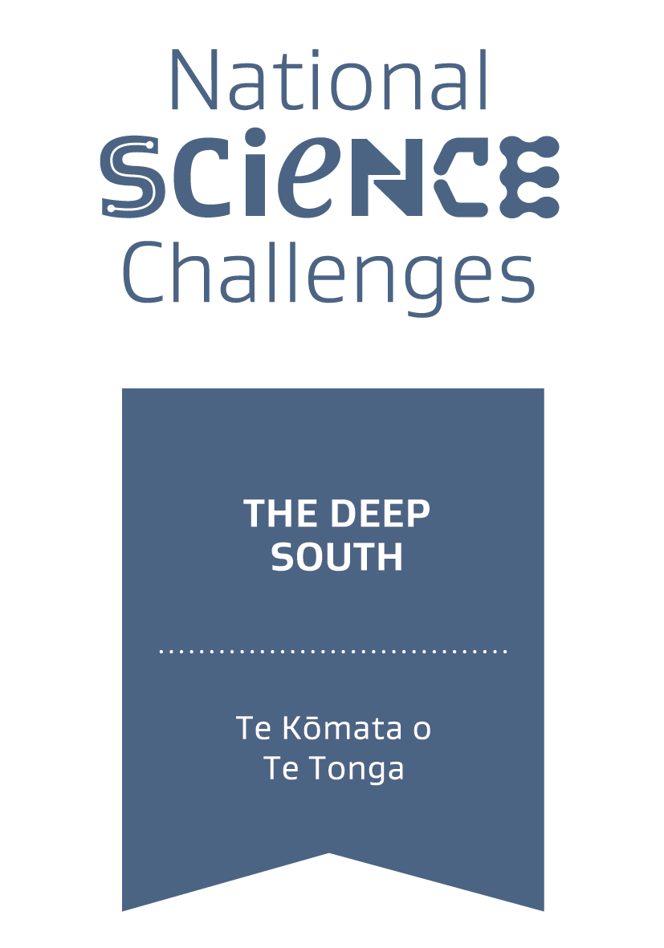
Kīanga puaki whitawhita
He pūtea mā ngā hapori Māori me ngā kairangahau Māori e urupare panoni āhuarangi nei

Te Kōmata o Te Tonga : Mā te panoni tahi me te huri āhuarangi tēnei kua toko ake te kīanga puaki whitawhita nā ngā kairangahau, mātanga mātauranga, pakihi māori, hapori māori anō hoki.

Tō īmēra: _____________________________________________________________________

Tēnā whakamāramatia mai, nō hea koutou, ko wai mā koutou?

Tōu ingoa: ______________________________________________________________________

Tō hapū / iwi: ___________________________________________________________________

Tō nama waea: __________________________________________________________________

Tō hapori / rōpū / whare mahi / ohu mahi (Ko te hunga whakahaere kirimana mēnā ki te angitū tō kaupapa):

_______________________________________________________________________________
_______________________________________________________________________________

Ko tēhea pūtea e tonoa nei?
- Te Aho
- Te Taura
- Aua hoki - me whaikupu pea ki te ope taunaki

Ngā mema pū o tō ohu o tō rōpū rangahau rānei (E ngana nei kia mohio ake he aha rā ngā pūkenga, whēako me ngā mātauranga tērā e hihiko ai. Kia 100 pū ngā kupu whakautu.)

_______________________________________________________________________________
_______________________________________________________________________________
_______________________________________________________________________________

Ngā mema pū o tō ohu o tō rōpū rangahau rānei (E ngana nei kia mohio ake he aha rā ngā pūkenga, whēako me ngā mātauranga tērā e hihiko ai. Kia 100 pū ngā kupu whakautu.)

_______________________________________________________________________________
_______________________________________________________________________________
_______________________________________________________________________________

He aha nei tō kaupapa matua e whaipānga ana ki te wātaka pūtea rangahau panoni āhuarangi nei? (Taihoa iho kei ngā uiui e whiwhi wā ai koe ki te tuhi whakaahua mai i tō kaupapa kia taipitopito ake. Tēnā mai koa he whakarāpopototanga, he tuhinga kounga whakataurite mō tō kaupapa matua)

_______________________________________________________________________________
_______________________________________________________________________________
_______________________________________________________________________________

Whai tikanga tonu te kaupapa nei ki tētahi, ētahi rānei o ngā aronga matua? (Tirohia ngā ara tohutohu mō ngā whakamārama. Ki te kore e whai tikanga, nei ka hiahia kia rongo tonu atu i a koe.)
- Āe
- Kao
- Aue hoki

Ruku hōhonu: Kohikohi whakamārama e pā ana ki tāu tūtohi rangahau

He aha nei ō moemoeā, ngā wawata me ngā manako rānei o tō hapori e pā ana ki tēnei rangahau?
E ngana nei kia mōhio ake pēhea rā te tautoko a tō rangahau kia toitū tonu ai te āhuarangi, te hauora, te whakawhanake ā hapori ā motu rānei. Kia 200 kupu pū hei whakautu.

_______________________________________________________________________________
_______________________________________________________________________________
_______________________________________________________________________________
_______________________________________________________________________________

He aha nei ngā whāinga pito mata a tō rangahau me ngā hua ka puta?
Tohua kia tatauria mai ngā whāinga/putanga ( kia 1 ki te 3 ki te 4 rānei whāinga) kia 200 kupu pū hei whakautu. Mēnā e pūrangiaho ana tō tukanga rangahau ki a koe, tēnā tukua mai ngā whakamārama whānui tonu. Kia 200 kupu pū.

_______________________________________________________________________________
_______________________________________________________________________________
_______________________________________________________________________________
_______________________________________________________________________________

I te whaipānga o ngā whāinga rangahau, ko tēhea o ēnei rerenga kupu e hāngai nei hei whakaahua i tō ohu, tō rōpū rānei.
- E tino māia nei mātou ki tā mātou tūtohi rangahau otirā tērā e rite mō te tuku tono pūtea rangahau inā karangatia.
- E āhua māia nei mātou ki tā mātou tūtohi rangahau, engari me whakarite tonu ake i ētahi taipitopito.
- E whakatau tonu ana mātou i ō mātou whāinga rangahau pito mata.
- E whakahuatau tonu ana mātou.
- Arā noa atu.

Me kupu whakaahua mai i te pēheatanga o te matāuranga māori e hihiko ai i tō rangahau. Mēnā he ritenga pūtaiao kē hei whenumi mai, whākina mai. Kia 200 kupu pū.

_______________________________________________________________________________
_______________________________________________________________________________
_______________________________________________________________________________
_______________________________________________________________________________

Tahua tūtohu
- $50K - $100K
- $100K - $150K
- $150K - $250K
- Aua hoki

Kia tārua ō urupare/whakautu mai ki te puka kūkara nei. Mō te tūpono ka raru i te puka kūkara nei, īmeratia mai tāu puka kua oti kē ki a: mailto:deepsouth@niwa.co.nz

