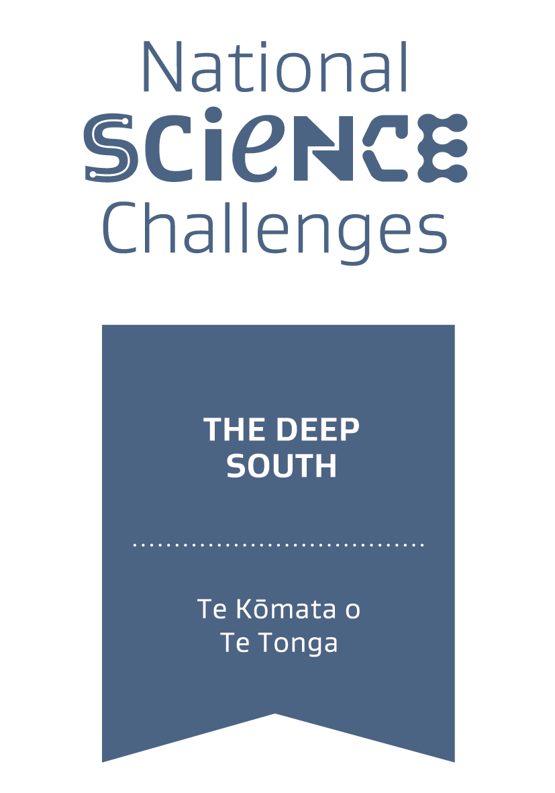
Expression of Interest
Funding for Māori communities & Māori researchers
responding to climate change

The Deep South Challenge: Changing with our Climate invites Expressions of Interest (EoIs) from researchers, practitioners of mātauranga, pākihi and hāpori Māori.

Your email: _____________________________________________________________________

Tēnā whakamāramatia mai, nō hea koutou, ko wai koutou?

Your name: _____________________________________________________________________

Your hapū | iwi: _________________________________________________________________

Your phone number: _____________________________________________________________

Your hāpori / rōpu / institution / organisation (Those who will be involved in contracting if the project is successful):

_______________________________________________________________________________
_______________________________________________________________________________

What fund are you applying for?
- Te Aho
- Te Taura
- Unsure - interested in speaking to the Engagement Team

Key members of your rōpū or research team (We’re interested in the range of skills, experience and knowledges you might activate. Please limit your response to 100 words.)

_______________________________________________________________________________
_______________________________________________________________________________
_______________________________________________________________________________

Which community do you intend will benefit most from this research? (For example, the name of the marae, papakāinga, hāpori, hapū or iwi where your research will be grounded. If your research is regional or national in focus, please give details.)

_______________________________________________________________________________
_______________________________________________________________________________
_______________________________________________________________________________

What is your main kaupapa, in relation to this climate research funding round? (In later questions, you’ll have an opportunity to describe your project in more detail. Here, please provide a short summary or high-level perspective of your main kaupapa.)

_______________________________________________________________________________
_______________________________________________________________________________
_______________________________________________________________________________

Does this kaupapa speak to one or more of the focus areas and priorities? (Please see our webpage for more information. If it doesn’t, we’d still like to hear from you.)
- Yes
- No
- Unsure

Diving deeper: Gathering information about your research

What are your (or your community’s) moemoeā | aspirations in relation to this research? (We are interested in how your research might support climate resilience, wellbeing, and community or national transformation. Please limit your response to 200 words.)

_______________________________________________________________________________
_______________________________________________________________________________
_______________________________________________________________________________
_______________________________________________________________________________

What are your potential research goals and potential outcomes? (Please number these goals/outcomes, and provide anywhere from 1 to 3 or 4 goals. Please limit your response to 200 words.)

_______________________________________________________________________________
_______________________________________________________________________________
_______________________________________________________________________________
_______________________________________________________________________________

In relation to your research goals, which of the following statements best describes your team or rōpū?
- We’re feeling confident with our proposed research and will be ready to submit an RFP if/when invited
- We’re reasonably confident with our proposed research, but still need to work through some of the details
- We’re still working through our potential research goals
- We’re just at the conceptualisation phase
- Other

Please describe how mātauranga Māori might be activated through your research. If your project may also use or blend other science methods, please give details. If you have clarity about your methodology, we invite you to share more information. Please limit your response to 200 words.

_______________________________________________________________________________
_______________________________________________________________________________
_______________________________________________________________________________
_______________________________________________________________________________

Indicative budget
- 50k -100k
- 100k - 150k
- 150k - 250k
- Aua hoki

Please copy your answers into the GoogleForm here. If you can’t use GoogleForms, you can email your completed form to: deepsouth@niwa.co.nz

