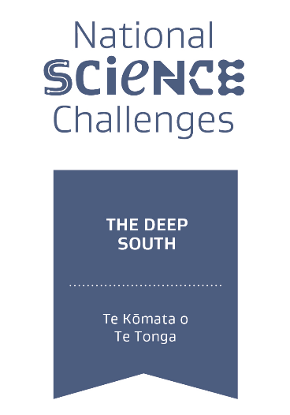
The Deep South – National Science Challenge

Science Leadership Team – Expressions of Interest
Expressions of interest are being sought for the role of Science Leadership Team (SLT) member for the Engagement Programme of The Deep South National Science Challenge.
The Challenge will undertake and coordinate research that contributes to the Challenge Objective “To understand the role of the Antarctic and Southern Ocean in determining our climate and our future environment” in order to deliver the Challenge Mission “Enabling New Zealanders to adapt, manage risk, and thrive in a changing climate.” To achieve both, substantive and varied, research and engagement projects are being undertaken across five key Challenge Programmes: Engagement; Vision Mātauranga; Impacts and Implications; Earth System Modelling and Prediction; and Processes and Observations.
The goal of the Engagement programme is to contribute to improving New Zealanders’ ability and capacity to make decisions informed by Deep South Challenge -related research. This is delivered by focusing on six engagement objectives outlined in the Engagement Strategy and Executive Summary.
The Engagement science leadership position will provide strategic guidance, oversee reporting for the Deep South Challenge workstreams and project(s) and retain oversight of communication and engagement across the Challenge including at project level. They will guide and co-manage the Challenges Director of Partnerships and Senior Communication Advisor. All programme leaders also contribute to regular SLT meetings, and proposal reviews, as required. They will also play a leading role in the development of the Future Plan for the 5 year extension of the Challenge from 2019.
In order to deliver on the Mission, the Challenge is focused on effective and responsive end-user engagement and uptake. Experience with end-user engagement, engagement research and practice, and the climate change engagement landscape in Aotearoa New Zealand will be advantageous to the position, as will strong links and synergies with other Challenges and relevant networks. Institutional support/encouragement for the applicant holding this role (where applicable) is also advantageous.
Up to 0.2 FTE is available for this position until June 30, 2019 (the end of the current funding for the Challenge). If the Future Plan for 2019-24 is successful this position could be extended by mutual agreement into the second phase of the Challenge.
The SLT comprises the Challenge Manager, and one representative for each of the five Challenge Programme as is led by the Challenge Director, who reports to the Deep South Board. Other advisory groups (e.g., Kahui Maori, Engagement, and Independent Science Panel) provide external advice and Counsel to the Challenge at large.
For more information regarding this position please contact either the existing Engagement Programme Lead, Rhian Salmon (Rhian.Salmon@vuw.ac.nz), or the Challenge Director Williams (Mike.Williams@niwa.co.nz), with whom applications (CV and cover letter outlining your experience and interest in the role) should be submitted by 5pm, Monday 21 August.
For more information on the Challenge see www.deepsouthchallenge.co.nz

